
A 10
SET NO : 2

Sreenidhi Institute of Science & Technology
(An Autonomous Institution)
Code No: 101MA03

B. TECH. I – Year II – Semester Examinations, Aug, 2011 (Regular)
MATHEMATICS - II (Common to ME, CSE, IT)

Time: 3 Hours Max. Marks : 70

Note : No additional answer sheets will be provided.

Part-A (Objective Type)
Max.Marks:20

Answer all QUESTIONS.

1. Find the complementary solution for (D³-3D²+3D-1) y = 0.

2. Find 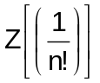.

3. State Green's theorem in a plane.

4. Without using partial fractions, evaluate 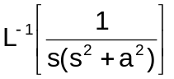.

5. If a function f(x) is defined in the interval [c,c+2L], and the transformation y=kx converts this function to g(y) and the interval to [d,d+2π], then k=? and d=?.

6. Solve the differential equation 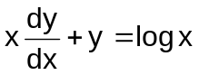 .
7. Is 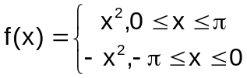even or odd? Find its Fourier series.

8. Find the unit normal vector at any point p (x, y, z) to the surface of a sphere with centre at the origin and radius as one unit.

9. Solve the differential equation (x²-ay) dx = (ax-y²) dy.

10. Evaluate 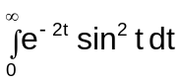, using Laplace transforms.

Part – B
Max. Marks: 50

ANSWER ANY FIVE QUESTIONS.
EACH QUESTION CARRIES 10 MARKS.

1. a) Define unit step function u(t-a). Find the Laplace transform of u (t-a) × f(t-a). [ 5 ]
Use this result in finding the Laplace transform of f(t) = 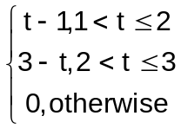.
b) Find the inverse Laplace transform of 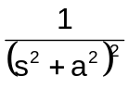using convolution theorem. [ 5 ]

2. Expand the function 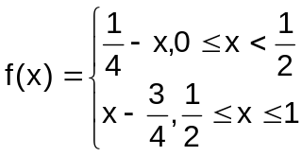as a Fourier series of sine terms. [ 10 ]

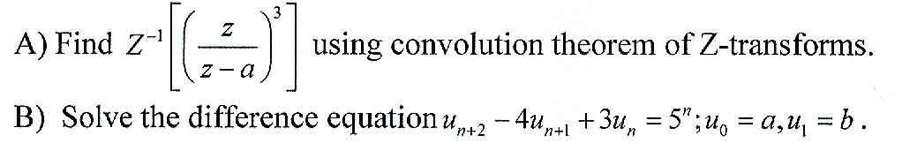
[ 5 ]
[ 5 ]
3.

4. a) Solve the differential equation 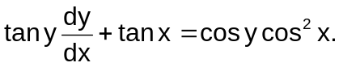 [ 5 ]
b) Find the orthogonal trajectories of the family of cardioids r = a (1- cosθ), a being parameter. [ 5 ]

5. a) Solve the initial value problem y⁽²⁾ (t) + 2y⁽¹⁾ (t) - y(t) = t, given that y(0)=0; y⁽¹⁾(0)=1. [ 5 ]

b) Find 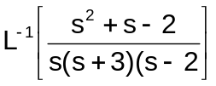. [ 5 ]
6.
[ 10 ]

7. Solve y|| + y = sinx + coshx + 2. [ 10 ]

8. Find the Fourier series expansion of the function defined as f(x+2π)=f(x) and f(x)=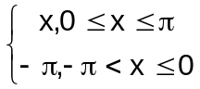. Hence, deduce that 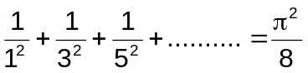. [ 10 ]

-- 00 -- 00 --

